JOE LOMBARDO

Governor

STATE OF NEVADA

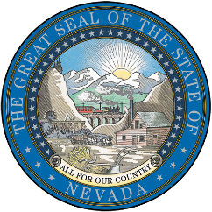
DWAYNE MCCLINTON
Director

MATTHEW BROWN

Deputy Director

GOVERNOR’S OFFICE OF ENERGY
600 E. William Street, Suite 200 | Carson City, NV 89701
energy.nv.gov | (775) 687-7189

Q&A Session: Understanding the 40101(d) Grid Resilience Grant Program

Friday April 25, 2025, 10:00 AM
Microsoft Teams
Join the meeting now
Meeting ID: 226 102 452 929 9
Passcode: ab28US3C
Dial in by phone
+1 775-321-6111,,30089628# United States, Reno
Find a local number
Phone conference ID: 300 896 28#

Join us for an open Q&A session focused on the U.S. Department of Energy’s Grid Resilience Grant Program – Section 40101(d). This session is designed to help eligible entities, including utilities, and potential project partners—understand the program requirements, eligibility criteria, application structure, and cost share considerations.

Topics will include:
- Who is eligible to apply and how partnerships can be structured
- Types of resilience projects that are eligible
- Cost share requirements and how they are determined
- Roles of lead applicants and subrecipients

This is an informal and interactive session—come with your questions!

Please forward this invitation to any stakeholders that might be interested.

Link to NOFO and Application
https://energy.nv.gov/Resources/Federal_Funding_Opportunities/40101d/

